* 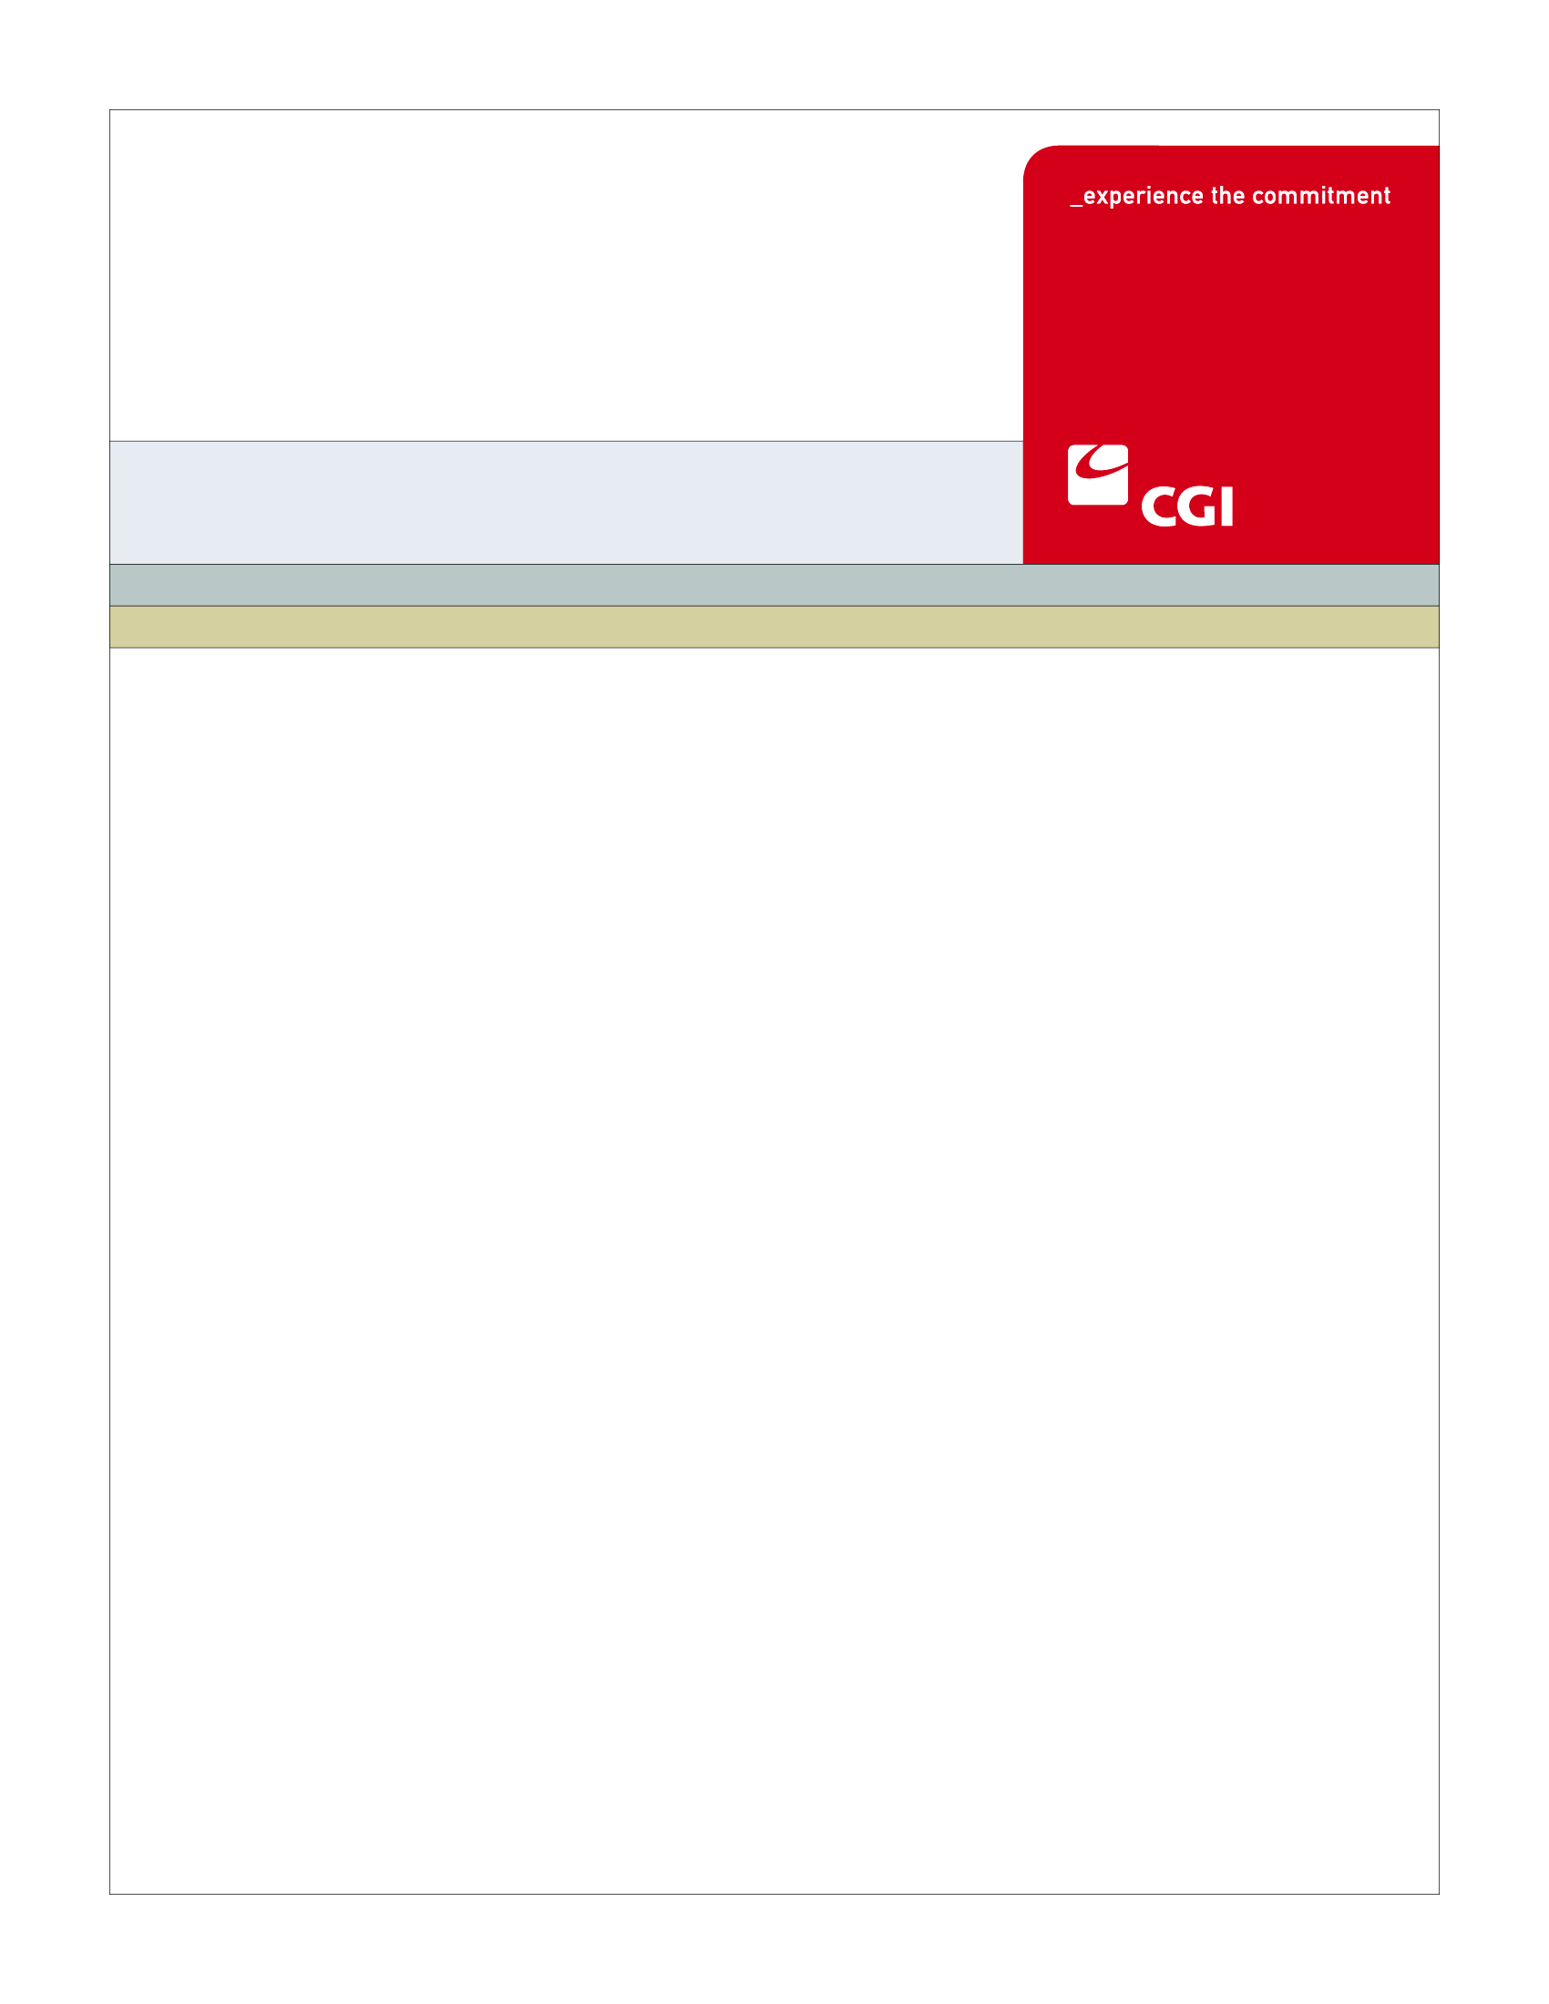USE

**AM-005 Create Carrier Account Use Case**

**Colorado Health Benefit Exchange (COHBE)**

**Version 0.3**

**November 9, 2012**

REVISION HISTORY

|  |  |  |  |
| --- | --- | --- | --- |
| Version | Date | Modified By | Description |
| 0.1 | 10/24/2012 | Rob Merry | Initial Draft |
| 0.2 | 10/30/2012 | Rob Merry | Incorporating comments from Discovery |
| 0.3 | 11/9/2012 | Rob Merry, Diane Dunn | Incorporating comments from Elaboration |
|  |  |  |  |

TABLE OF CONTENTS

1 Use Case: Create Carrier Account 5

1.1 Goal 5

1.2 Brief Description 5

1.3 Requirements Traceability 5

1.4 Primary Actor 5

1.4.1 COHBE 5

1.5 Secondary Actor 5

1.5.1 Carrier Portal 5

1.6 Pre-Conditions 6

1.7 Successful Post-Conditions 6

1.8 Triggers 6

1.9 Assumptions 6

2 Flow of Events 6

2.1 Basic (Main) Flow – Create Account 7

2.1.1 Register to Create an Account 7

2.1.2 Enter Basic Account Information 7

2.1.3 Existing Account for Carrier? 7

2.1.4 Create Account 8

2.1.5 Send Notification Email 8

2.1.6 Next Steps 8

3 Alternate Flows 8

3.1 Duplicate Account 8

3.1.1 Duplicate Account Error Message 8

3.1.2 Issue Resolvable? 8

4 Exception Flows 9

4.1 Issue is not resolvable 9

5 Specifications 9

5.1 Business Rules 9

5.2 Process Rules 9

5.2.1 Does Carrier have an Account 9

5.3 Workflow 9

5.4 UI Screen Details 9

5.4.1 Create Account 9

5.5 Communications 10

5.5.1 Imaging Requirements 10

5.5.2 Form Requirements 10

5.5.3 Notice Requirements 10

5.5.4 Other Communication Requirements 10

5.6 Interfaces 10

5.7 Reporting 10

5.7.1 User Experience 10

5.7.2 Business Activity 11

5.7.3 Workflow 11

5.7.4 Community and Public Health 11

5.8 User Security 11

5.8.1 Actor Status Changes 11

5.8.2 Sensitive Data Used 11

5.9 Activity Log and Audit Trail 11

5.10 Data Elements 12

6 Future Release Notes 13

7 Appendix A - Glossary 13

# Use Case: Create Carrier Account

## Goal

The goal of this Use Case is to successfully create a Carrier account to log into the Carrier Portal to Certify the Carrier and load Carrier plans.

This Use Case completes succesfully when the account is created and the Carrier has a unique user ID and password to log into the Carrier Portal.

## Brief Description

A Carrier account must be established to allow access to get certified and allow the Carrier to load plans through SERFF to the Carrier Portal. COHBE will create an account on behalf of the Carrier. This will be done by entering the required data to create the carrier’s account. A validation step will be done to confirm there is not an existing account. If no existing account is found, the account will be created and a notification will be sent to the Carrier.

## Requirements Traceability

The following requirements are covered within this Use Case:

GF077: Third parties such as carriers, navigators and brokers each will have an entry point into the Exchange in order to perform all of their required activities.

PM016: The System will create an account for each Carrier.

## Primary Actor

### COHBE

COHBE staff will create Carrier Accounts based on the Carrier requesting an account.

## Secondary Actor

### Carrier Portal

The Carrier Portal will be used to create the Carrier Account

## Pre-Conditions

The Carrier provides information needed to have an account created on their behalf.

## Successful Post-Conditions

* The Carrier account is created by COHBE with a status of new and the Carrier is notified with a unique user ID and password
* Data elements listed as required in section 5.10 are populated.

## Triggers

* The Carrier notifies COHBE they intend to offer plans on the Exchange

## Assumptions

* COHBE will create the first user for a Carrier Account.

# Flow of Events

The Business Process Activity diagram below shows the COHBE processes for the Create Carrier Account Use Case. The steps numbered on the diagram below have detailed explanations in the sections that follow.



## Basic (Main) Flow – Create Account

When COHBE enters the required information to create a Carrier Account and there is not an existing account, the data base will create a record for the Carrier.

### Register to Create an Account

COHBE will log into as an admin user to create a carrier account.

### Enter Basic Account Information

With information provided by the Carrier, COHBE will enter the basic account information needed to create an account for the Carrier.

### Existing Account for Carrier?

After entering the basic account information, a check will be performed to verify an existing account does not already exist. If an existing account is found, proceed to alternate flow step 3.1.1, Duplicate Account Error Message (Process Rule, Existing Account for Carrier, 5.2.1). If no existing account is found proceed to step 2.1.4, Create Account.

### Create Account

An account is created if an existing account is not found for the Carrier.

### Send Notification Email

After successfully creating the Carrier account, an email notification will be sent to the Carrier user with next steps, user ID and temporary password.

### Next Steps

Based on information that was updated, user can proceed to various next steps, such as:

PM-001 Certify Carrier Use Case

PM-003, PM-004 Manage Carrier Information Use Cases

# Alternate Flows

## Duplicate Account

If an existing account is found in step 2.1.3, then proceed to step 3.1.1.

### Duplicate Account Error Message

If an existing account is found, then an error message will be displayed indicating the Carrier account is already in the Portal.

### Issue Resolvable?

COHBE will determine if the issue is resolvable to create the Carrier Account. If the issue is resolvable, then proceed to step 2.1.2, Enter Basic Account Information. If the issue is not resolvable, the Use Case ends.

# Exception Flows

## Issue is not resolvable

The Use Case will end if the duplicate error message is not resolvable.

# Specifications

## Business Rules

There are no business rules for the Create Carrier Account Use Case.

## Process Rules

### Does Carrier have an Account

Step 2.1.3 will check for an existing account associated with the user based on the basic information fields. A verification will be performed to check:

* Check the NAIC Number
* Alternately, check for duplicate HIOS numbers if the field is valued.

## Workflow

There will be no workflow for the Create Carrier Account Use Case.

## UI Screen Details

### Create Account

Fields on the UI in the Carrier Portal will be used to create a Carrier Account. The fields needed, will be included on the table below:

| Data Field | Add/Modify/Remove | Sort | Filter | Plan Rows |
| --- | --- | --- | --- | --- |
| Legal Name | * Add | * N/A | * N/A | * N/A |
| First Name | * Add | * N/A | * N/A | * N/A |
| Last Name | * Add | * N/A | * N/A | * N/A |
| NAIC Number | * Add | * N/A | * N/A | * N/A |
| HIOS Number | * Add | * N/A | * N/A | * N/A |
| User ID | * Add | * N/A | * N/A | * N/A |
| Password | * Add | * N/A | * N/A | * N/A |

## Communications

### Imaging Requirements

There are no Imaging Requirements for the Create Carrier Account Use Case.

### Form Requirements

There are no Form Requirements for the Create Carrier Account Use Case as email is expected to be sufficient for the account information needed.

### Notice Requirements

#### Notify Carrier

* Carrier will receive a notification from the Exchange with account information
* Notification will explain next steps for the Carrier, User ID and Temporary Password

### Other Communication Requirements

There are no Other Communication Requirements for the Create Carrier Account Use Case.

## Interfaces

There are no Interfaces associated to the Create Carrier Account Use Case.

## Reporting

### User Experience

There are no User Experience Reporting needs for the Create Carrier Account Use Case.

### Business Activity

There are no Business Activity Reporting needs for the Create Carrier Account Use Case.

### Workflow

There are no Workflow Reporting needs for the Create Carrier Account Use Case.

### Community and Public Health

There are no Community and Public Health Reporting needs for the Create Carrier Account Use Case.

## User Security

### Actor Status Changes

No status changes occur in this Use Case. If a data change causes a status change, the triggered Use Case will update the status.

### Sensitive Data Used

No sensitive data will be exposed during this Use Case.

## Activity Log and Audit Trail

There are no special Activity Log and Audit Trail for the Create Carrier Information Use Case.

## Data Elements

This section lists data elements created as part of the process steps performed to satisfy this Use Case.

| Process Step Reference  **\*Required Field** | Field Name  **\*Required Field** | Required Field? | Action Taken | Actor Performing Action | Format, if known |
| --- | --- | --- | --- | --- | --- |
| 2.1.2 | Carrier Account ID | * Yes | * Created upon submit | * System | * Numeric or Alpha-Numeric * System generated to identify the carrier account in the Data Base |
| 2.1.2 | First Name | * Yes | * Created | * User | * Alpha Characters |
| 2.1.2 | Last Name | * Yes | * Created | * User | * Alpha Characters |
| 2.1.2 | Carrier Status | * Yes | * Created upon submit | * System | * Set to New after record is created |
| 2.1.2 | Log in ID | * Yes | * Created | * User | * Alpha-Numeric |
| 2.1.2 | Password | * Yes | * Created | * System | * Alpha-Numeric-Special Characters * System Generated |
| 2.1.2 | Legal Name | * Yes | * Created | * User | * Alpha-Numeric |
| 2.1.2 | NAIC Number | * Yes | * Created | * User | * Numeric |
| 2.1.2 | HIOS Number | * No | * Created | * User | * Numeric |

# Future Release Notes

SERFF may interface with the Carrier Portal to create Carrier Accounts.

# Appendix A - Glossary

| Term | Definition |
| --- | --- |
| SERFF | System for Electronic Rate and Form Filing |
| NAIC Number | National Association of Insurance Commissioners Number |
| HIOS Number | Health Insurance Oversight System Number |